Saturday, Aug 13, 2022
Sponsorship Form
The Humane Society of Aurora is a non-profit, 501(c)3 organization (47-3361286) that was established in February 2015.

Since its inception, we at the Humane Society of Aurora (HSA) have worked tirelessly to improve outcomes and provide enrichment for the animals staying at local shelters and animal control facilities.

Please check sponsorship level
 | Paw Pal-$100 | Name on Table & Recognition on website
 | Best Friend-$250 | Name on Table, Recognition on website & Name on T-shirt
 | Pack Leader-$500 | Name on Table, Recognition on website & Name on T-shirt & flyer

HSA provides financial assistance to local shelters, animal control facilities and rescues so that they can provide medical care to those animals that require extraordinary veterinary care. HSA also helps low-income families in the community by providing food or veterinary care for their pets and educates families and individuals about responsible pet ownership.

Sponsor Name:
Address, City, State & Zip:

Contact Person: _ Email:
Phone:

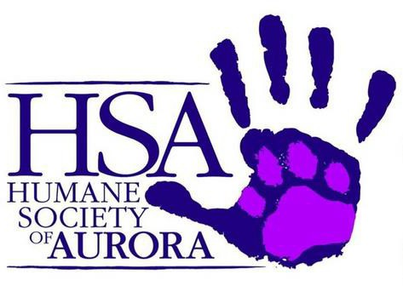
Please mail form and payment to: Humane Society of Aurora, ATTN: Rescue Ride, 2112 W. Galena Blvd., Suite 8 #472 Aurora, IL 60506

Questions or to donate items please contact: humanesocietyofaurora@gmail.com

